**Using Scratch to Teach Event-Driven Coding Skills**

**Step-by-Step**

Pages 3-6 ………………………………………. General Set-up

Pages 7-25 ………..………………………………………. Level 1

Pages 26-31 ………………………………………………. Level 2

Pages 32-38 ………………………………………………. Level 3

Start by going to <https://github.com/TAP-GGC/makeysrace>. Then click on the code folder and select the incomplete code. This will contain all 3 levels of the game.

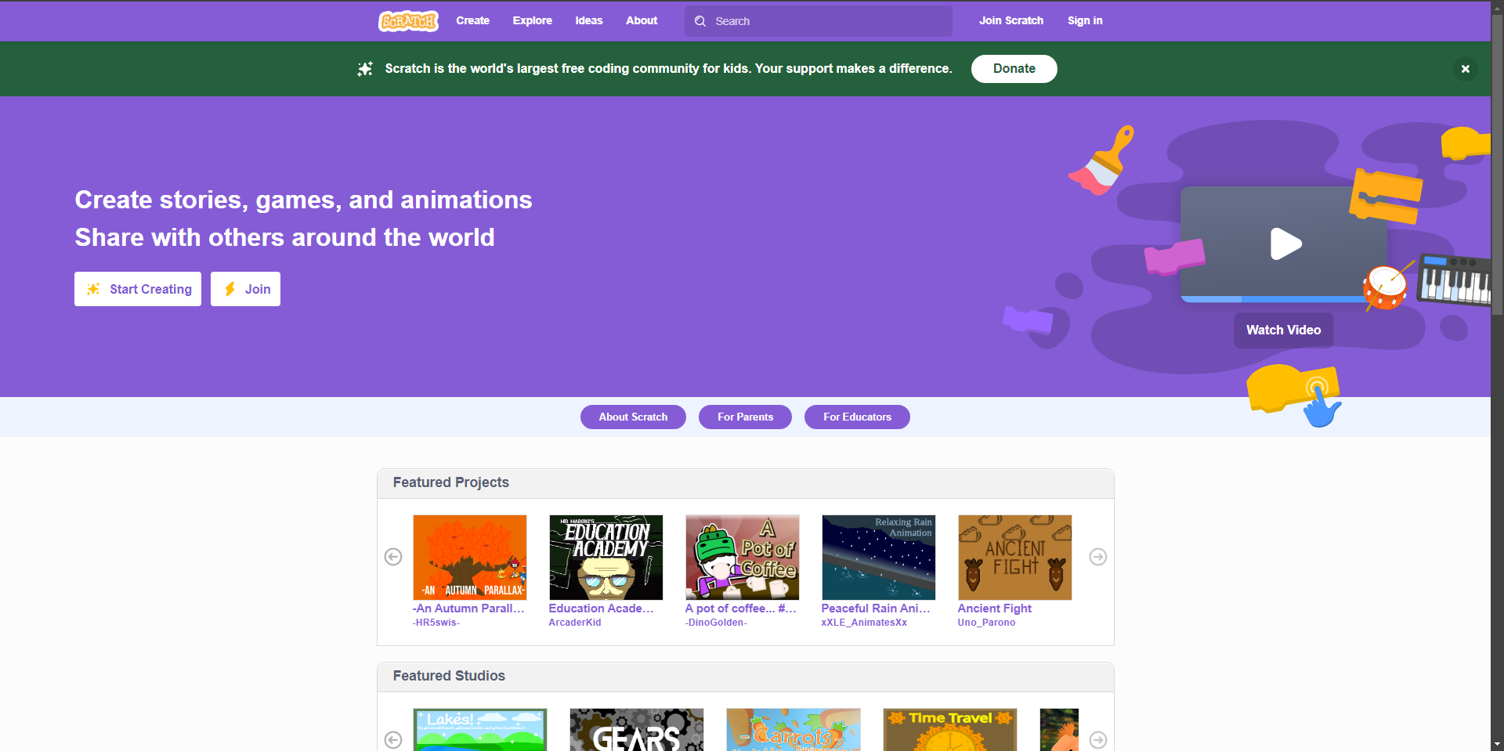After you download the file, go to <https://scratch.mit.edu/> and then click on create.

Now click on “file” and then “Load from your computer.” Then select the file that was just downloaded from GitHub. It should be called “IncompleteCode.sb3”.**This section will cover level 1 of the game.**

Make sure that the white ball is the selected sprite. Now click on “Events” on the left side of the screen. Then click and drag the “when flag clicked” and drop on an empy space on the canvas.

Now go to “Control” and grab the “forever” loop and attach it to code block.

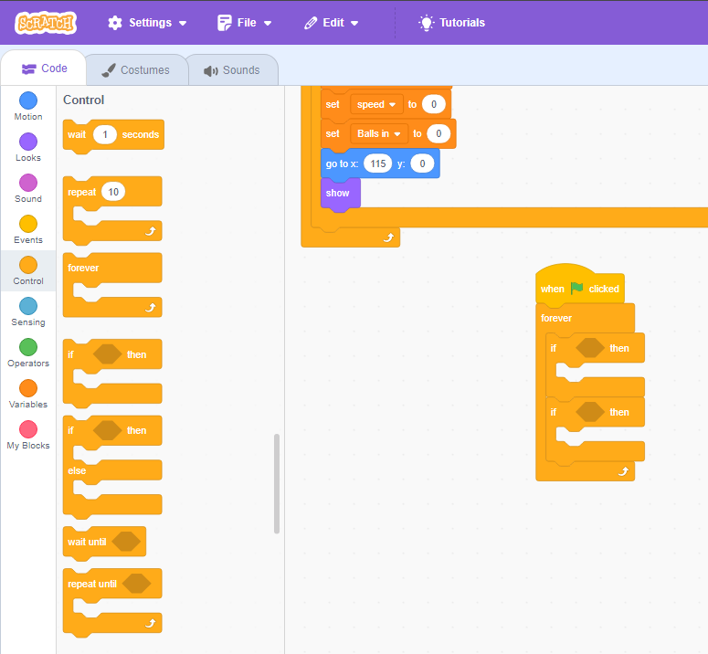Now grab 2 “if-then” blocks and put them into the “forever loop” like shown below.

We will focus on the top “if-then” block for now. Go to “Operators”. Then grab the “__ and __” block and put it into the blank in the “if-then” block. Then grab the “__ < 50” block and put it into the second blank of the “__ and __” block.

Go to “Sensing”. Grab the “touching mouse pointer?” block and insert it into the first blank of the “if-then” block. Then grab a “backdrop # of Stage” block and insert it into the “__ < 50” block. Change the mouse pointer to “ball 1” and “backdrop # of Stage” to “speed of ball 1”.

Now go to the “Variables” tab and grab the “speed” variable. Insert it into the “__ < 50” block.

Go to “sounds” and grab the “start sound hit ball” and put it into the “if-then” statement.

Go to “Control” and then grab the “wait 1 seconds” block and insert it into the “if-then” statement. Then go to “Variables” and grab the “set balls in to 0” block and put it into the “if-then” statement. Change the variable to speed. A screenshot of a computer
Change the wait time from 1 to 0.05 seconds. Then go to “Operators” and grab the “__ /__” block and put it into the “set speed to __” block. Then go to “Variables” to grab the speed variable and put it into the first blank of the “__ /__” block. Then type 3 for the last blank. It should look like the section shown below.

Go to “Motion” and grab the “turn counterclockwise 15 degrees” block and put it into the “if-then” statement. Then go to “Operators” and grab the “__ - __” block and put it into the “turn counterclockwise 15 degrees” block.

Go to “Sensing” and grab the “backdrop # of Stage” and add it to the first blank. Change variables so it says, “direction of ball 1”. Then go to “Motion” and grab the “direction” block and attach it to the second blank. Then go to control add grab the “wait 1 seconds” block and change it to 0.25.

The second “if-then” block is very similar to the first. Insert the same blocks in the “if-then” blank, but grab “__>__” instead of the “__<__”.

Go to the “Motion” tab and grab the “point towards mouse-pointer” block and change it “point towards ball 1”. Then add a “turn clockwise 15 degrees” block. Keep the same degree.

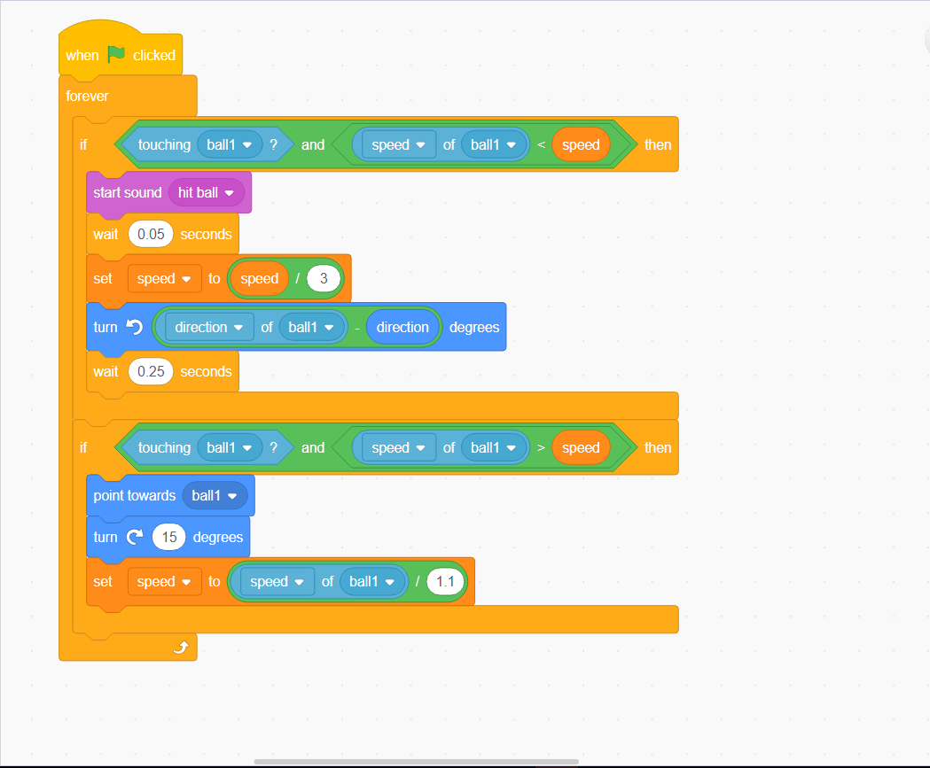Go to the “Variables” tab and grab the “set balls in to 0” block and change the variable to “speed”. Then go to “Operators” and grab the “__/__”. Then go to “Sensing” and grab the “backdrop # of Stage” and insert it into the first blank. Change it to “speed of ball 1”. Then type 1.1 in the second blank.

Go to the “Control” tab and grab the “wait 1 second” block. Change the block so it will wait 0.25 seconds.

Click on the “when flag clicked” block in the code and then use ctrl+c to copy the code block. Now select the “ball 1” sprite. Use ctrl+v to paste the code onto the canvas. You may need to move around the canvas to find the code block.

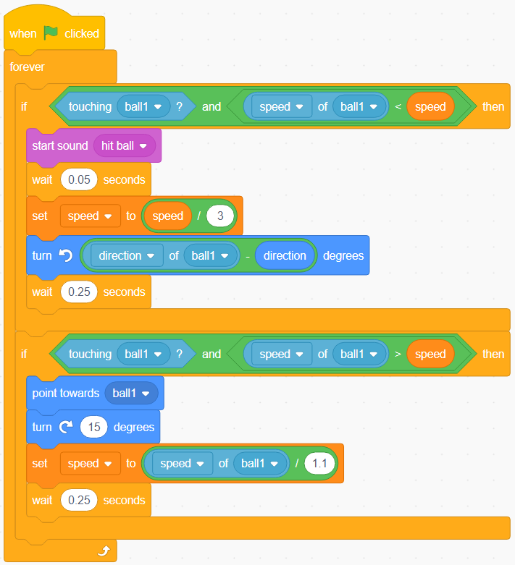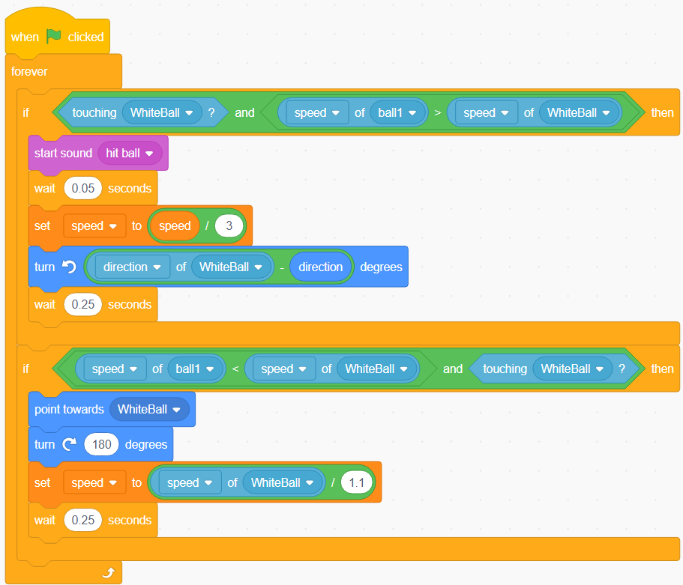Now we have to change all instances of “ball 1” to “white ball”. Make sure that the block is still checking for speed not direction. We also have to change the “turn clockwise 15 degrees” block to “turn clockwise 180 degrees”. Use the two pictures below to compare the different code blocks.

Code block in “white ball” sprite

Code block in “ball 1” sprite

**This section will cover level 2 of the game**

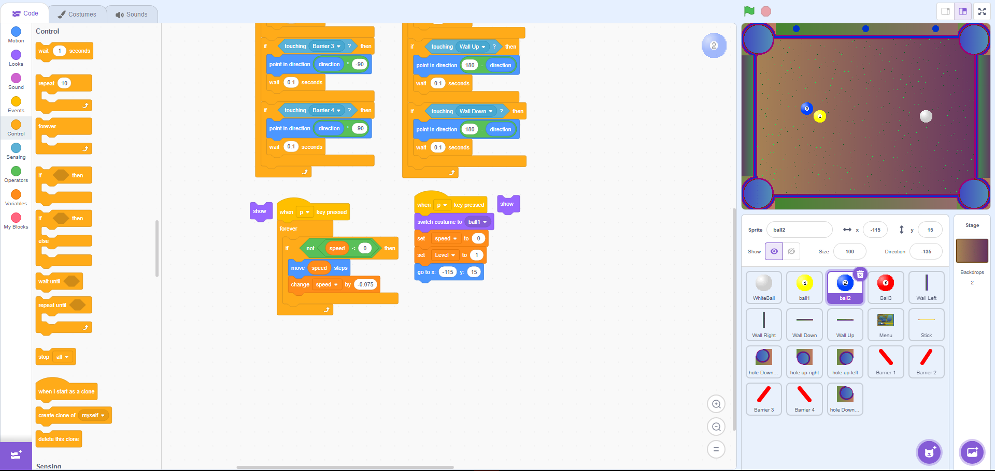First go to the “ball 2” sprite and click on the eyeball to make the ball visible. Then attach the two “show” block to the adjacent code blocks they are next to.

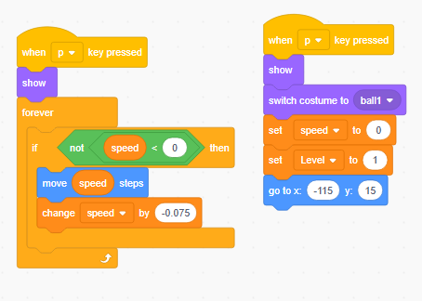

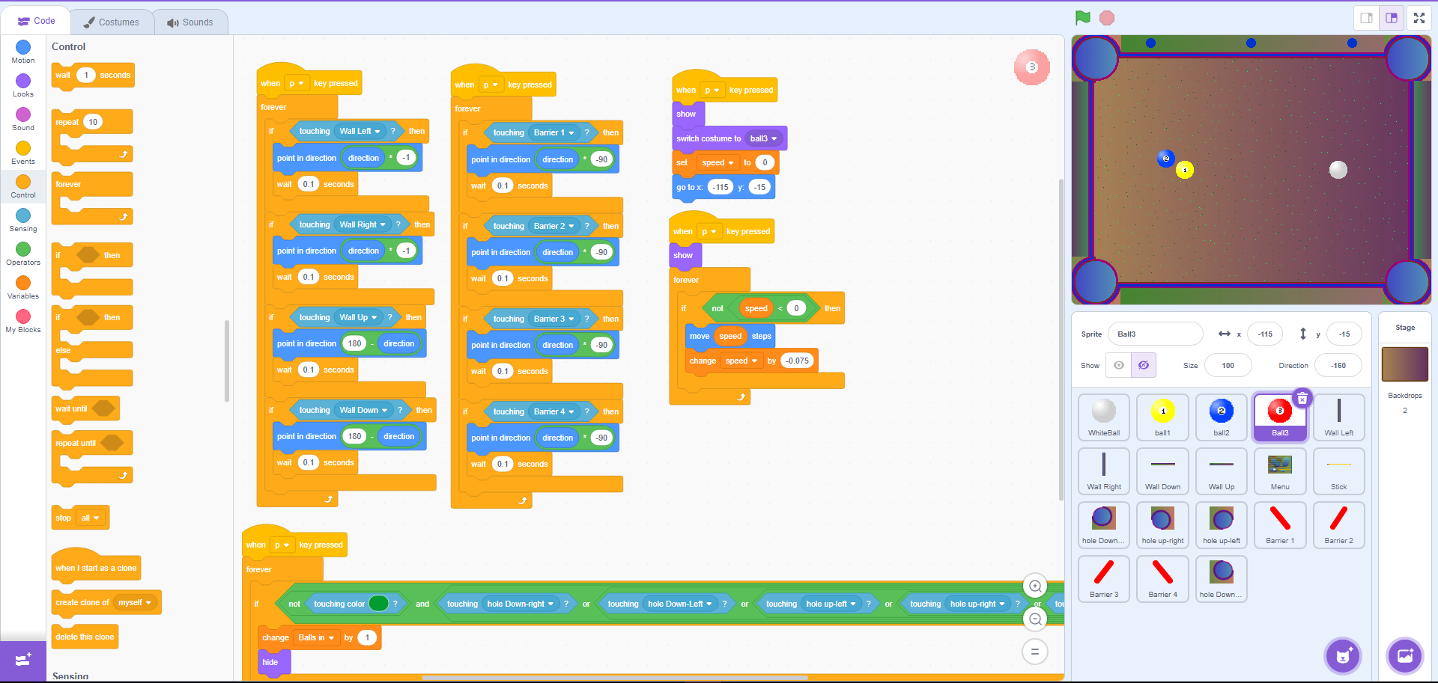Repeat this process for ball 3.

Select the “white ball” sprite and create the same code block as the one in level 1. Change all instance of “ball 1” to “ball 2”.

Now repeat the same process in the ball 1 sprite and the ball 2 sprite. The correct code for the interactions for the white ball, ball 1, and ball 2 are provided below. Now try to create the code for ball 3.

**This section will cover level 3 of the game**

Go to each of the barriers and click on the eyeball to make them visible.

Go to the “Events” tab and select the “when flag pressed” block. Then go to the “Motion” tab and grab a “set x to __” and a “set y to __” block. Change the x to 60 and the y to 30.

Go back to the “Events” tab and grab the “when flag pressed” block. Then go to the “Control” tab and grab a forever loop.

Go to the “Motion” tab and grab two “glide __ secs to x:__ y:__” and insert them both inside the forever loop. Set the glide to 1 sec for both. Set the x to 30 and y to 60 for one of the glide blocks. Then set the x to 90 and y to 30 for the other.

This is a similar process for the remaining barriers. Below is the code for the barrier 2.

Below is the code for barrier 3.

Below is the code for barrier 4.